BOOKING FORM

**Creative Bible Journalling Retreat**

Tuesday 4th – Friday 7th February 2020

at Whitchester Christian Centre nr Hawick

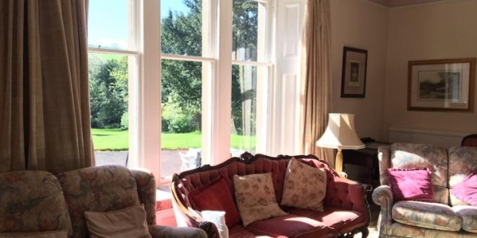Enjoy 3 nights of creative space in the beautiful Scottish Borders. Using the Book of Ruth as inspiration, come and enjoy some peace for prayer and reflection, think about God’s faithfulness to us, and explore the challenge of what it means to be faithful Christians in the world today. Sessions will include: background to Ruth, benefits of creative journalling, different techniques, how and why you might lead Bible journalling where you are, plus lots of free time for journalling in the craft room. All sessions are optional.

The retreat will run from teatime on Tuesday 4th February 2020, until after breakfast on the morning of Friday 7th. Whitchester Christian Centre TD9 7LN, is 2 miles South of Hawick just off the main A7 on the B711 Roberton Road. For map and public transport links, see the Whitchester website [www.whitchester.org.uk](http://www.whitchester.org.uk).

Accommodation is in single occupancy rooms with ensuite-shower. Full board is included, plus morning coffee and afternoon tea. We have sole use of the building including craft room, sitting room, conservatory, and grounds with woodland prayer walk. All craft and journalling materials, plus study notes on Ruth are included. Bring your own Bible! The cost is £360 per person.

To book your place, please return this form with a non-refundable deposit of £45. The balance of £315 is due by Monday 30th Dec 2019. You cabpay the full amount now if you prefer. In case of cancellation, the balance cannot be refunded after 30th December.

Name:

Email:

Tel:

Dietary requirements and any other needs:

Please tick as applicable:

* I wish to book a place on the Retreat at Whitchester 4-7th February 2020.
* I enclose a cheque for my deposit of £45 payable to Jane MacLaren, 8 Keith Terrace, Edinburgh EH4 3NJ
* I have paid the £45 deposit by direct bank transfer. Account name: Jane MacLaren, sort code: 09-01-26, account no: 05634319
* I have also paid the balance now (full amount £360)
* I will pay the balance by 30th Dec 2019
* I understand that the deposit of £45 is non-refundable and the balance cannot be refunded after 30th Dec 2019.

Signed:……………………………………................................................

Places are limited to 10. Please return your form as soon as possible if you would like to come.

[jane@creativejournalling.co.uk](mailto:jane@creativejournalling.co.uk) 8 Keith Terrace, Edinburgh EH4 3NJ, [www.biblejournalling.co.uk](http://www.biblejournalling.co.uk)